

Analytics using Tableau

UPx academy certification exam

Manoj Kalamkar | Data Science Super Specialization | June 10th, 2017

# Question 1

Load the dataset-1 and perform a monthly forecast analysis using the forecast option in the Analytics pane and write down the predicted value for April 2014

# Answer 1

Predicted Value for April 2014 = **12,297**

Tableau public link :

<https://public.tableau.com/views/UPxCertificationExam-Dataset1/Sheet1?:embed=y&:display_count=yes>

Image :

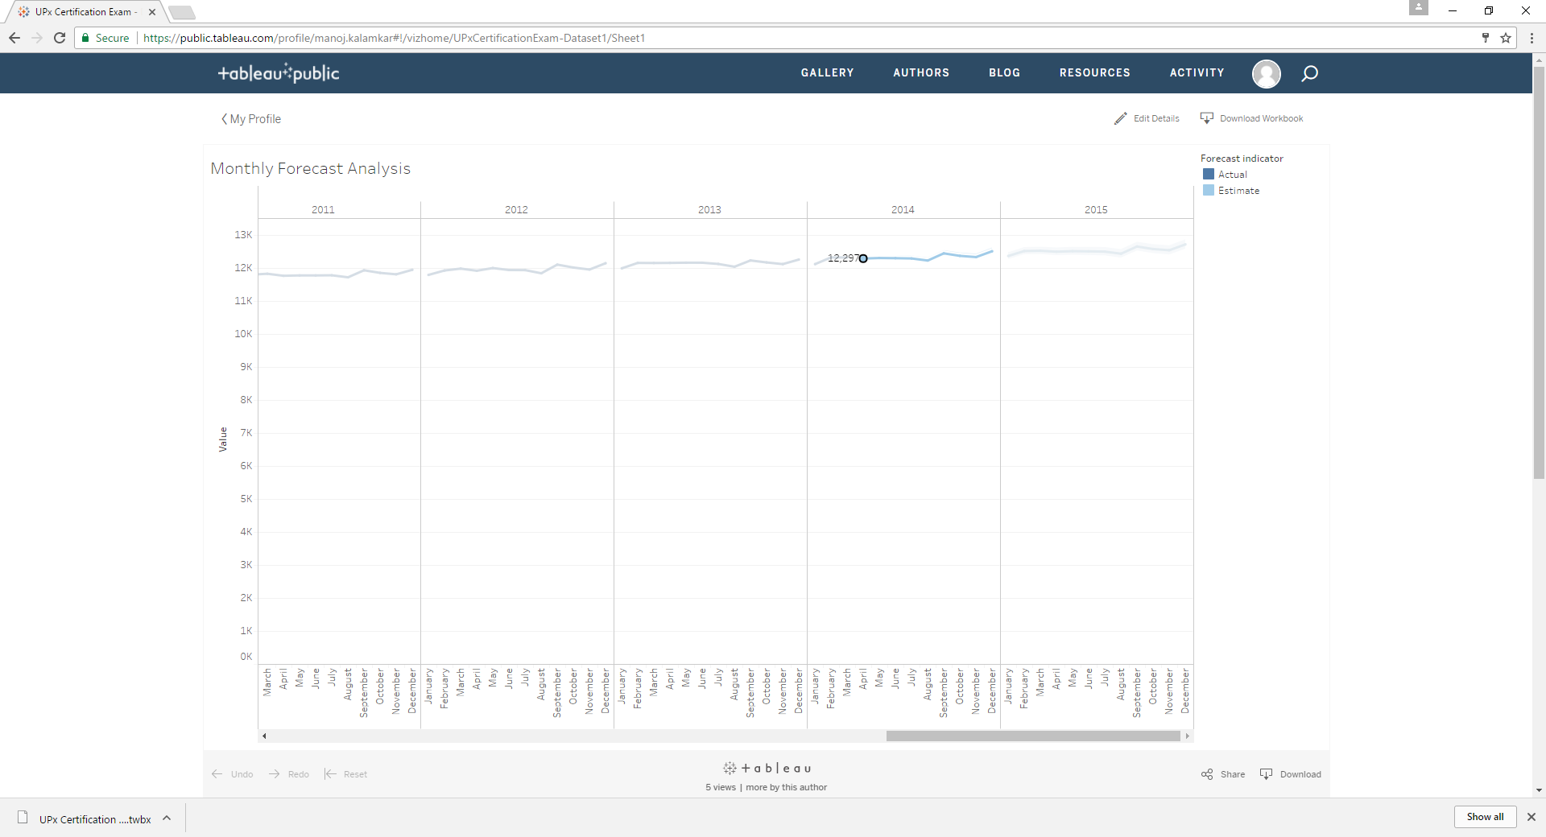

# Question 2

Data filters and instant calculations Topic: Load the sample superstore dataset and calculate the percentage of sales that were shipped through a JUMBO DRUM in March 2012

# Answer 2

Percentage of sales that were shipped through a JUMBO DRUM in March 2012

**21.81%**

Tableau public link :

<https://public.tableau.com/profile/manoj.kalamkar#!/vizhome/SuperstoreDataset_0/SouthernRegionProfit>

Image :

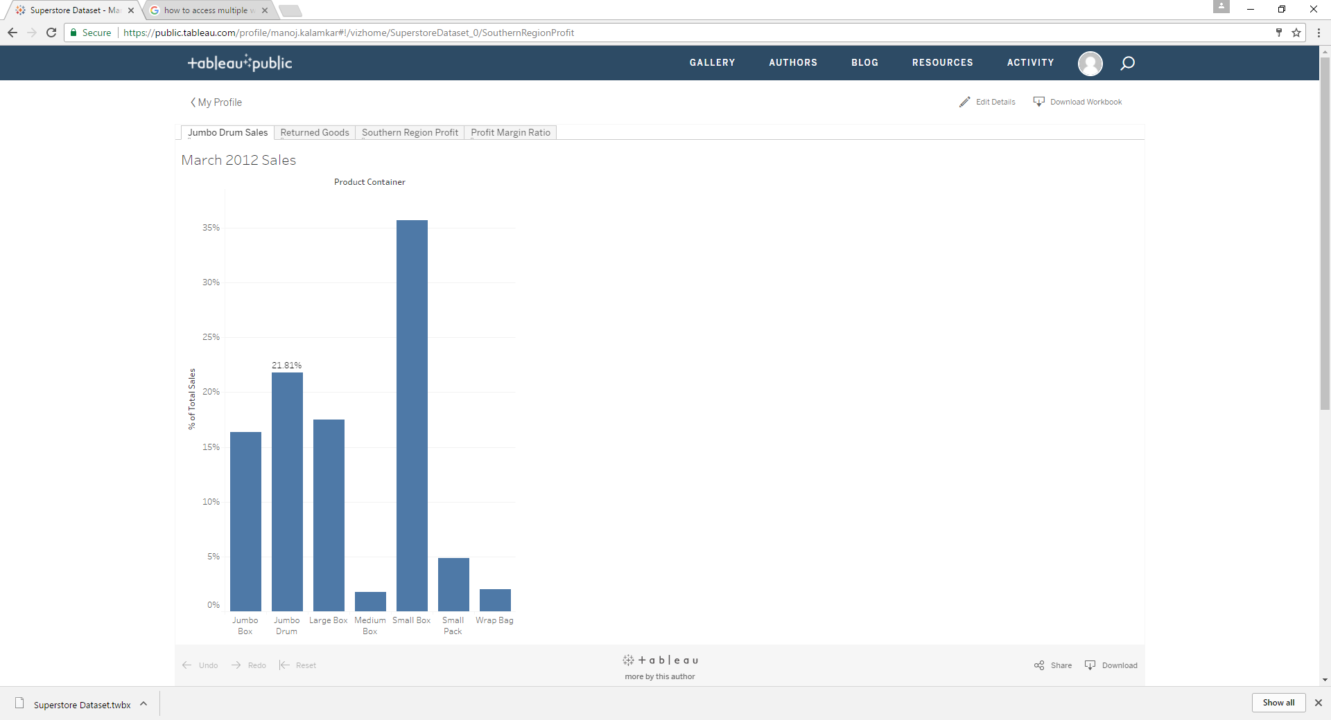

# Question 3

Data Joins and blends Topic: Load the sample superstore dataset and find the total value in sales revenues for the returned goods

# Answer 3

Total value of returned goods : **$8,951,931**

Tableau public link :

<https://public.tableau.com/profile/manoj.kalamkar#!/vizhome/SuperstoreDataset_0/SouthernRegionProfit>

Image :

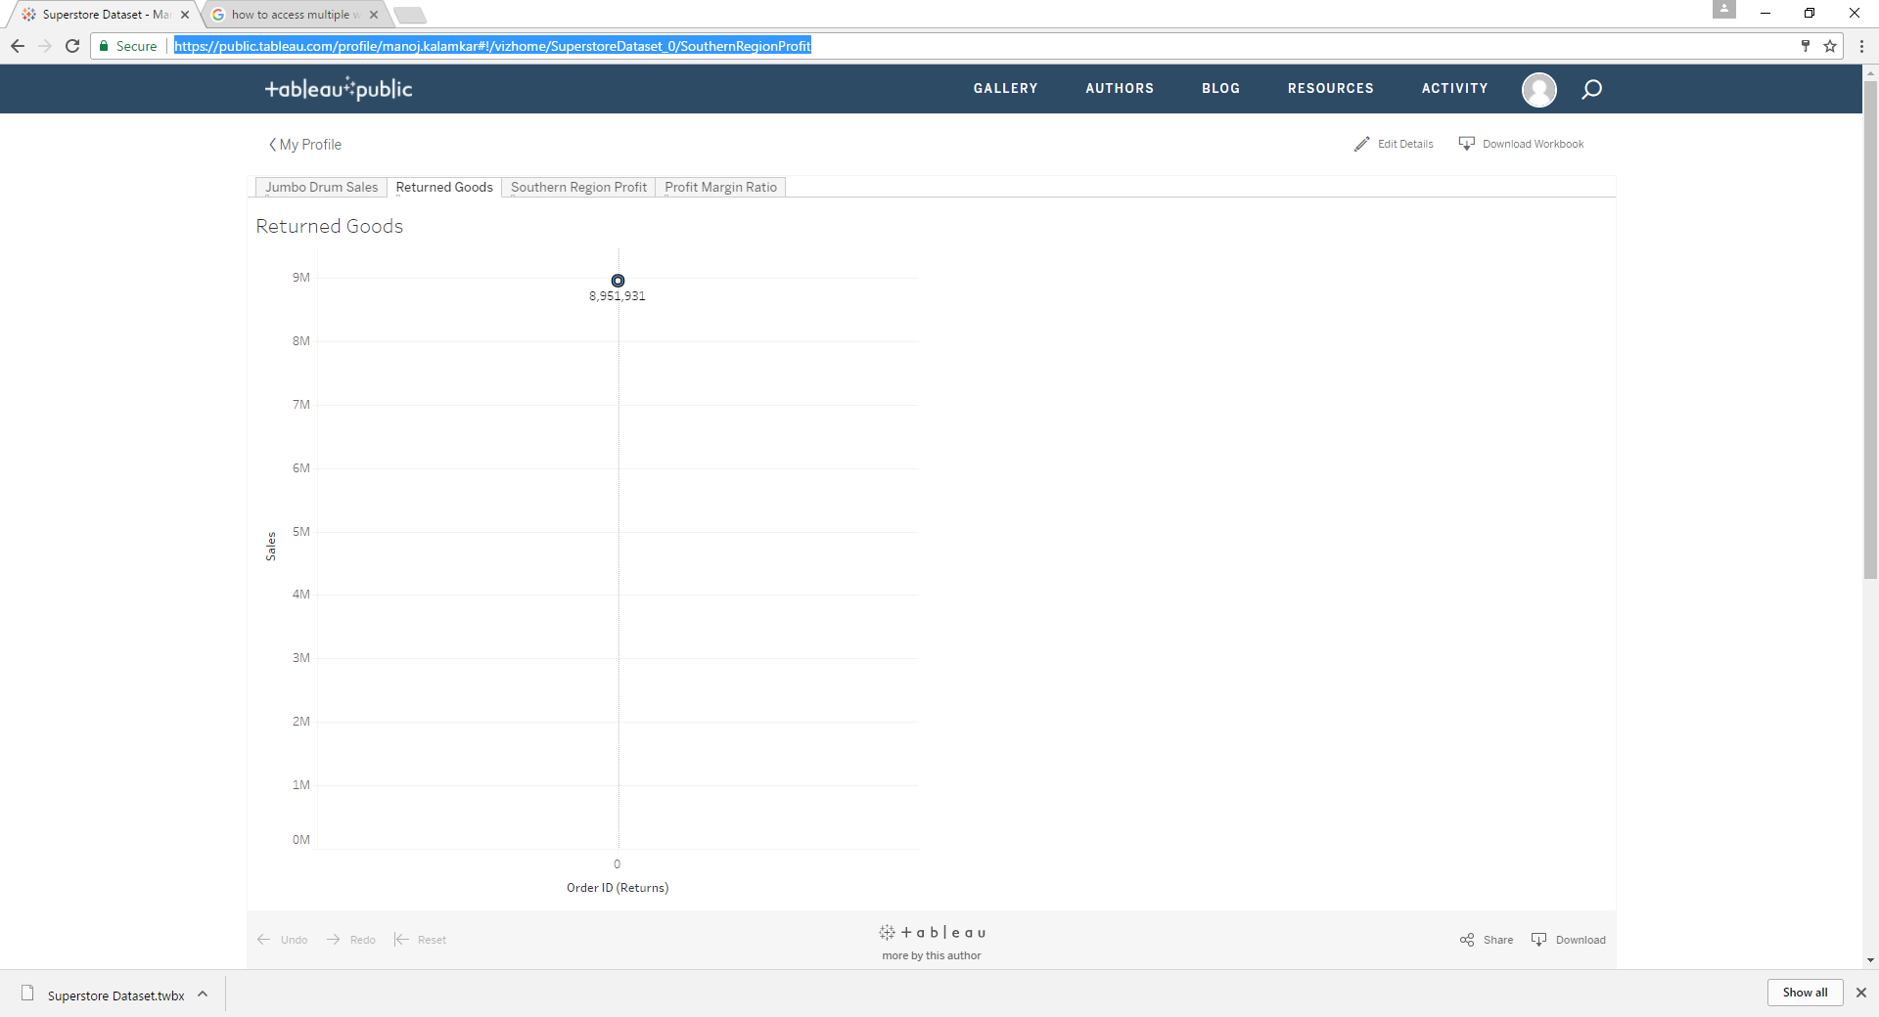

# Question 4

Calculations: What is the total profit for the Southern Region for the year 2013 and 2014 combined

# Answer 4

Total Profit : **$51,806**

Tableau public link :

<https://public.tableau.com/profile/manoj.kalamkar#!/vizhome/SuperstoreDataset_0/SouthernRegionProfit>

Image :

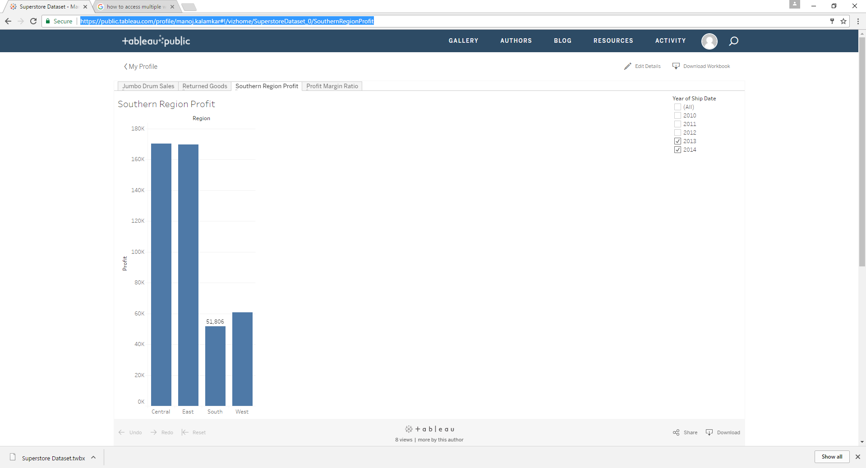

# Question 5

Create a calculated field formula to calculate the profit margin ratio

# Answer 5

Tableau public link :

<https://public.tableau.com/profile/manoj.kalamkar#!/vizhome/SuperstoreDataset_0/SouthernRegionProfit>

Image :

